Introduction to Artificial Intelligence and Machine Learning (CSN11601)
ASSIGNMENT-2
Name : Aayansh Niranjan Date : 07/09/2025
Reg_No.: 20253004
Q1. Create a list and perform the following methods

a) insert()
b) remove()
c) append()
d) len()
e) pop()
f) clear().

CODE :
l1=[12,48,51,56,59,43,13,235,124]
print("The list : ")
print(l1)
print("----------INSERT FUNCTION----------")
a=int(input("Enter the value you want to insert : "))
b=int(input("Enter the index at where you want to input the value : "))
l1.insert(b,a)
print("Element Inserted")
print(l1)
print("----------REMOVE FUNCTION----------")
c=int(input("Enter the value you want to remove : "))
l1.remove(c)
print("Element Removed")
print(l1)
print("----------APPEND FUNCTION----------")
d=int(input("Enter the value you want to append : "))
l1.append(d)
print("Element added at last")
print(l1)
print("----------LENGTH FUNCTION----------")
print("Length of the list is : ",len(l1))
print("----------POP FUNCTION----------")
print("Element Poped : ",l1.pop())
print(l1)
print("----------CLEAR FUNCTION----------")
l1.clear()
print("List Cleared : ")
print(l1)

OUTPUT : 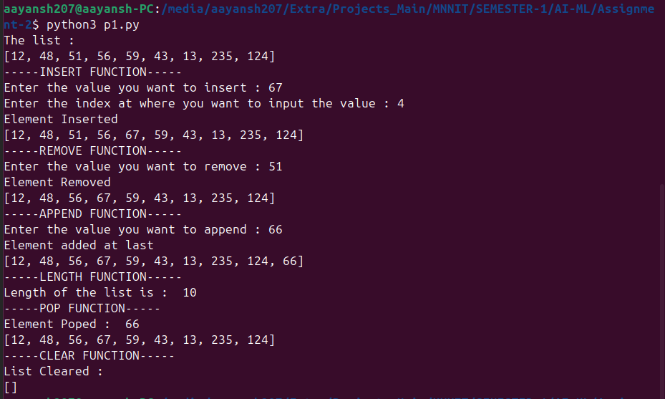

Q2. Write a Python function that takes two lists and returns True if they are equal otherwise false.
A2. CODE :
def test_list(l1,l2):
return l1==l2
list1=[]
list2=[]
print("For list 1")
n1=int(input("Enter the length of list : "))
for i in range(n1):
list1.append(int(input(f"Enter the {i+1} element : ")))
print("List 1 completed")
print("For list 2")
n2=int(input("Enter the length of list : "))
for i in range(n2):
list2.append(int(input(f"Enter the {i+1} element : ")))
print("list 2 completed")
print("Final output : ",test_list(list1,list2))

OUTPUT : 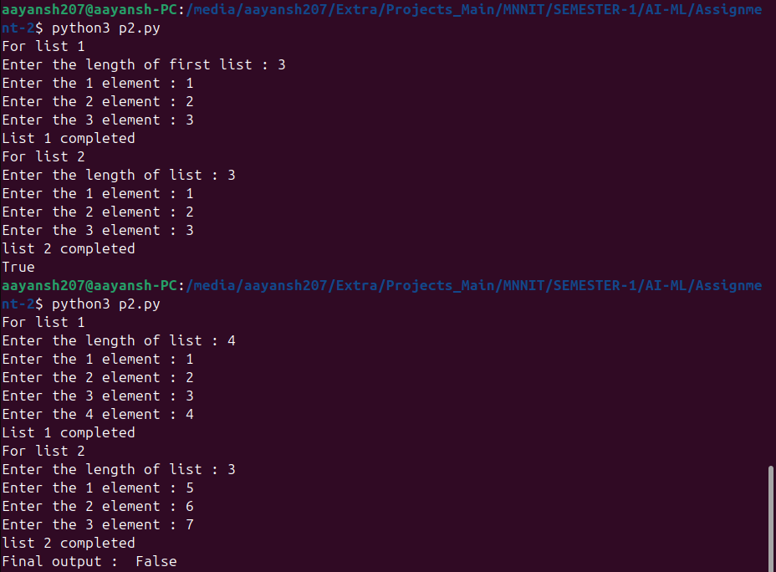

Q3. Create a tuple and perform the following methods

a) Add items
b) len()
c) check for item in tuple
d) Access items.

A3. CODE :
t1=(10,20,30,40)
l1=list(t1)
l1.append(50)
t1=tuple(l1)
print("Tuple after adding item:",t1)
print("Length of tuple:", len(t1))
print("Is 30 in tuple?", 30 in t1)
print("Is 100 in tuple?", 100 in t1)
print("First item:", t1[0])
print("Last item:", t1[-1])
print("Slice [1:4]:", t1[1:4])

OUTPUT : 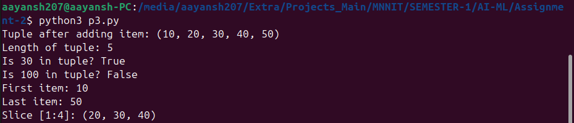

Q4. Write a Python program to enter name and percentage marks in a dictionary and display information on the screen.
A4. CODE:
students = {}
n = int(input("Enter number of students: "))
for i in range(n):
name = input(f"Enter name of student {i+1}: ")
percentage = float(input(f"Enter percentage of {name}: "))
students[name] = percentage
print("\nStudent Information:")
for name, percentage in students.items():
print(f"Name: {name}, Percentage: {percentage}%")

OUTPUT: 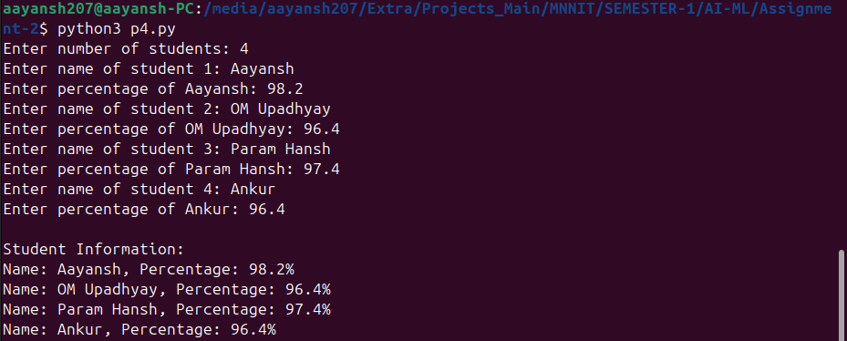

Q5. Write a program print duplicate element present in the list
A5. CODE :
list1 = []
n1=int(input("Enter the length of list : "))
for i in range(n1):
list1.append(int(input(f"Enter the {i+1} element : ")))
duplicates = []
for item in list1:
if list1.count(item) > 1 and item not in duplicates:
duplicates.append(item)
print("Duplicate elements:", duplicates)

OUTPUT :

